Run Cypress parallel using Github Action

Cypress is a good tool for End to End testing, and parallel is a feature that Cypress support to save the running time. When we want to run cypress test parallel, it need an account from Cypress Cloud but it is not free, you can see the price of Cypress cloud here: <https://www.cypress.io/pricing/#monthly>

In case we don’t have an account in Cypress Cloud, the remaining part of my article will show you how to run Cypress test in parallel without using Cypress Cloud.

## Install Cypress and example tests

At the time of writing this article, Cypress version is 12.13.0. I also kept 6 test specs from default Cypress’s examples for demonstrate.

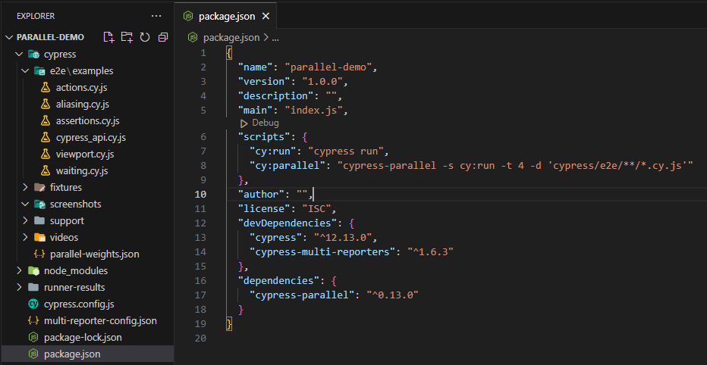

## Run parallel test in single machine:

From Cypress: *“While parallel tests can also technically run on a single machine, we do not recommend it since this machine would require significant resources to run your tests efficiently.”*

Let continue with steps below to understand why running cypress parallel tests in single machine is not recommend.

Install ‘Cypress-parallel’ <https://github.com/tnicola/cypress-parallel>

npm i cypress-parallel -D

Install ‘cypress-multi-reporters’ <https://www.npmjs.com/package/cypress-multi-reporters>

npm install cypress-multi-reporters --save-dev

Add scripts below to package.json

 "scripts": {

    "cy:run": "cypress run",

    "cy:parallel": "cypress-parallel -s cy:run -t 2 -d 'cypress/e2e/**/*.cy.js'"

  }

-s: Script to run

-t: number of threads

-d: path of test specs

Setup was done, now we will try to run tests serially and parallel using cypress-parallel and compare the timing and resource they spend.

First, try to run tests serially:

npm run cy:run

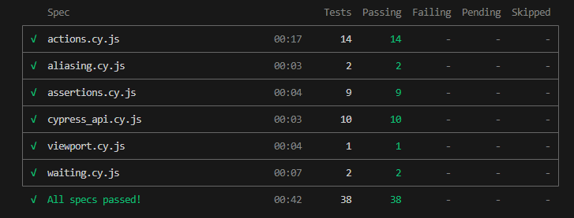

As the screenshot above, it takes 42 seconds to finish 38 tests, now let try with cypress-parallel in 2 threads:

npm run cy:parallel

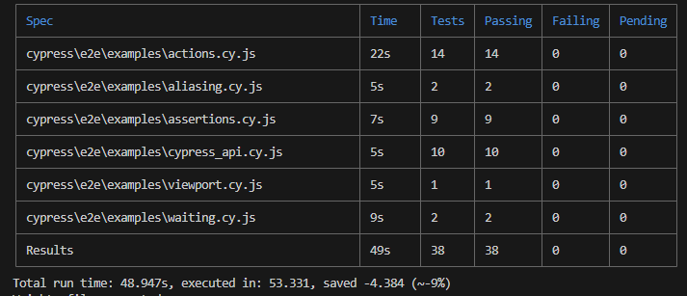

It took approx. 54 seconds to finish the test with 2 threads. Now we try the same test with 4 threads

npx cypress-parallel -s cy:run -t 4 -d 'cypress/e2e/**/*.cy.js'

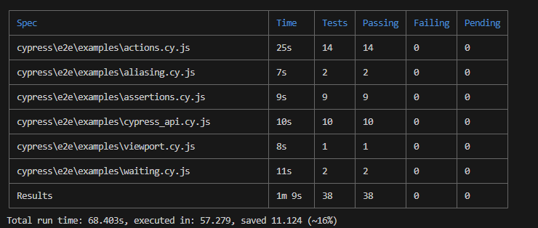

This time it took 57 seconds for execution, we can see both times running with cypress-parallel in single machine did not help to reduce the execution time when running serially. Parallel took 54 seconds in 2 threads and 57 seconds in 4 threads while serially only took 42 seconds. In addition, the CPU utilization also increased from 2% to 80-100% during running parallel tests.

|  |  |  |
| --- | --- | --- |
| Running 6 test in single machine | Execution time (seconds) | CPU utilization |
| Serially | 42 | 50% |
| Cypress-parallel (2 threads) | 53.331 | 80% |
| Cypress-parallel (4 threads) | 57.279 | 90-100% |

## Run parallel tests by utilizing GitHub Action: